**1.Data Set Preparation**

The pre-trained YOLOV5 model was chosen to set up this machine learning model. The main reason for using this model is that it is stable and easy to set up compared to many Computer Vision models**.**

First, the carpet pictures were grouped as 30 pictures for each color group from the-rugs.com website. The main purpose here was to create an object detection model based on the state colors.

There were about 14 color categories for different types of carpet models on the web-site.

These are:

* + - Beige
    - Black
    - Blue
    - Brown
    - Duck Egg
    - Green
    - Grey
    - Multicolor
    - Orange
    - Pink
    - Purple
    - Red
    - White
    - Yellow

But in these color categories; There was not enough carpet model on sale to train our model. In this context, it has been determined that the Yolo object detection model can be used to detect the color of different objects other than carpets. Objects other than carpet, such as car, pen, etc. defined by color in to the YOLOV5 model. Insufficient data in the dataset has been there by completed.

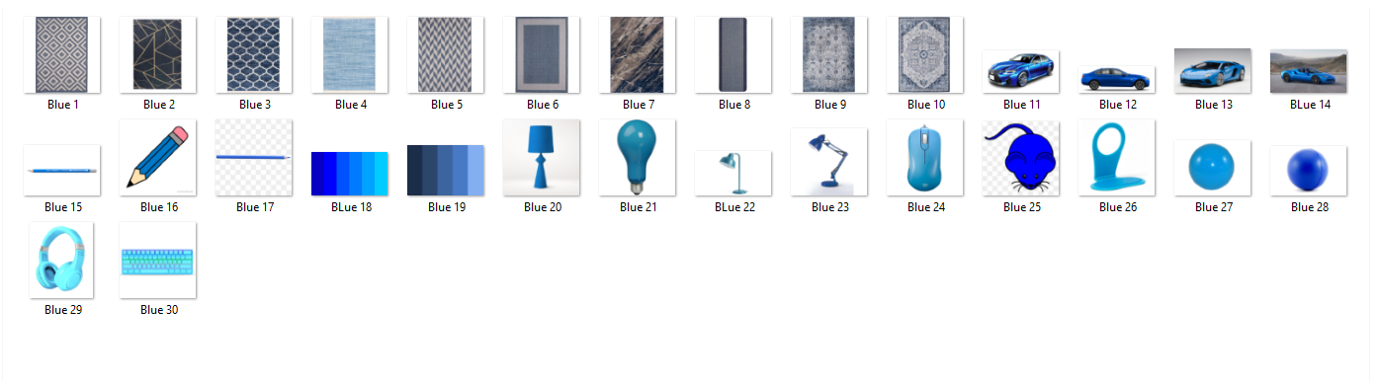

After reaching the sufficient number of images for the model in the data set, the images were labeled via makesenai.com.



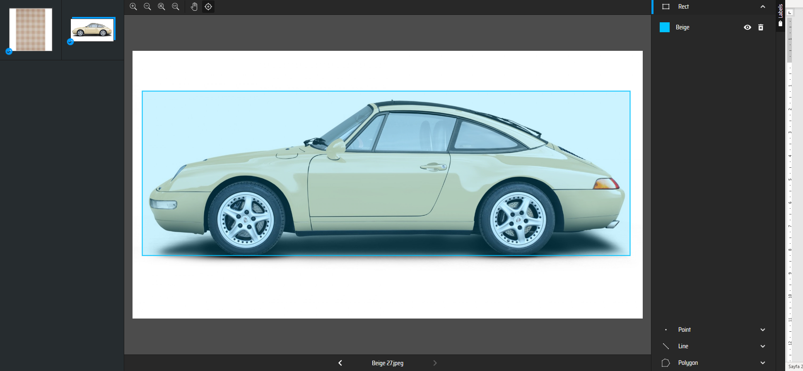

After labeling, labels and images were divided into two as train and validation. Here, 80% of the images and labels were allocated as test and 20% as validation.

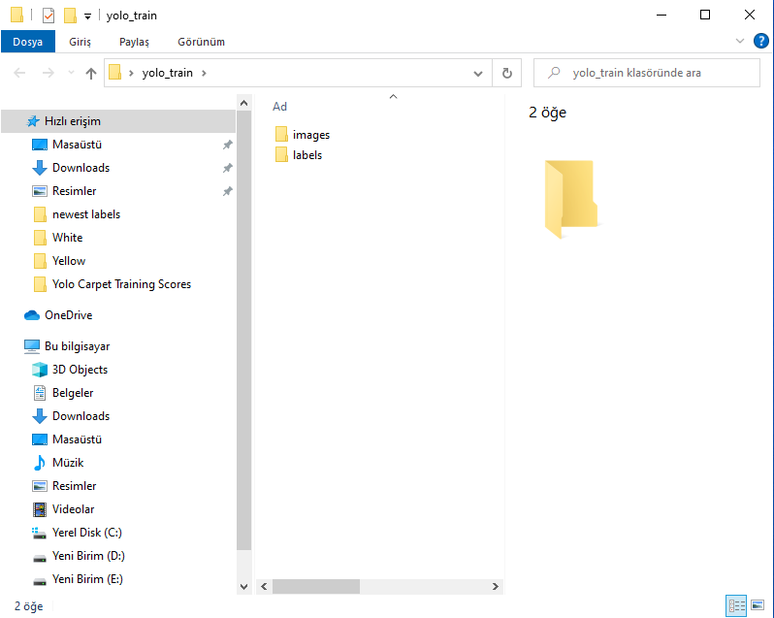

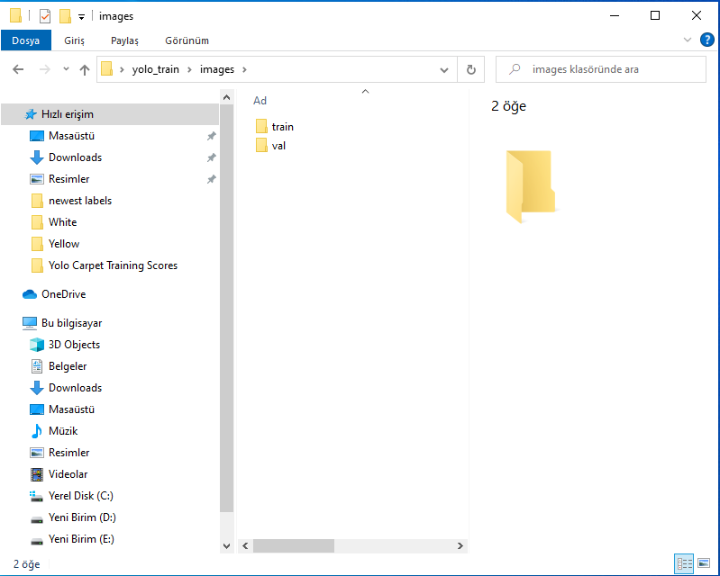

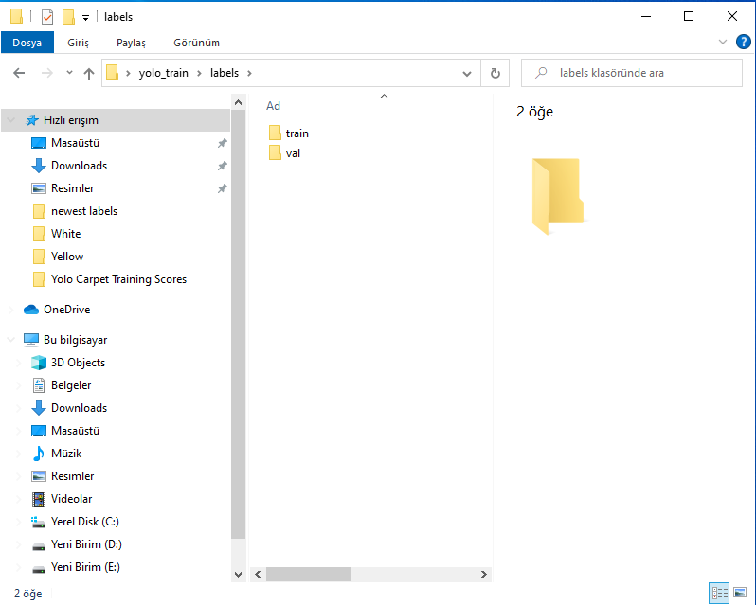

**2. Modelling**

The YOLOv5 GitHub repositor was used to set up the model. This respository was opened via Google Colab and the necessary downloads were made for the model. Then, the coco128.yaml file, which will make the necessary classification for the model, has been edited as follows.

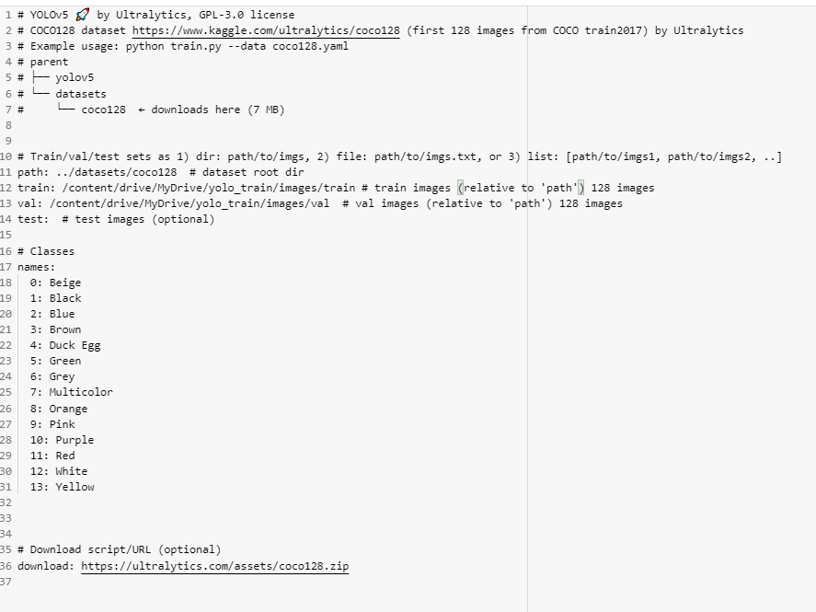

After editing the Coco128.yaml file, the necessary validation process for the model was performed. Along with this, the model recognized which object categories be detected.

!python val.py --weights yolov5s.pt --data coco128.yaml --**img** 640 --half

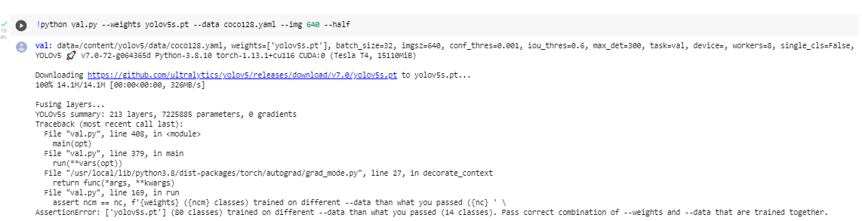

The model was trained with the following code block.

!python train.py --img 640 --batch 16 --epochs 70 --data coco128.yaml --weights yolov5s.pt --cache

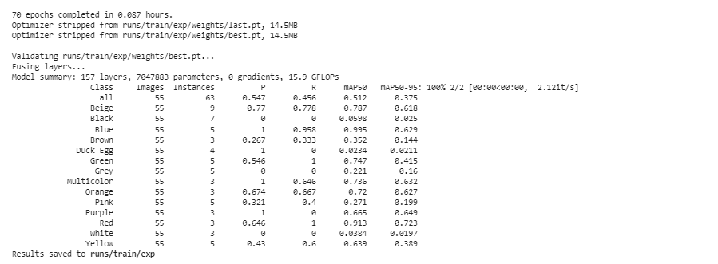

**3. Model Testing**

The detect command was used to see how well the model could detect. Below, we have seen that the model predicts beige color for a product in the orange category.

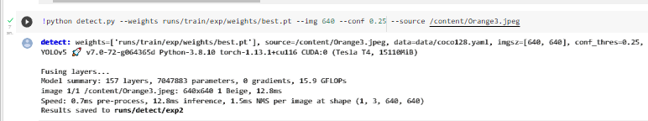

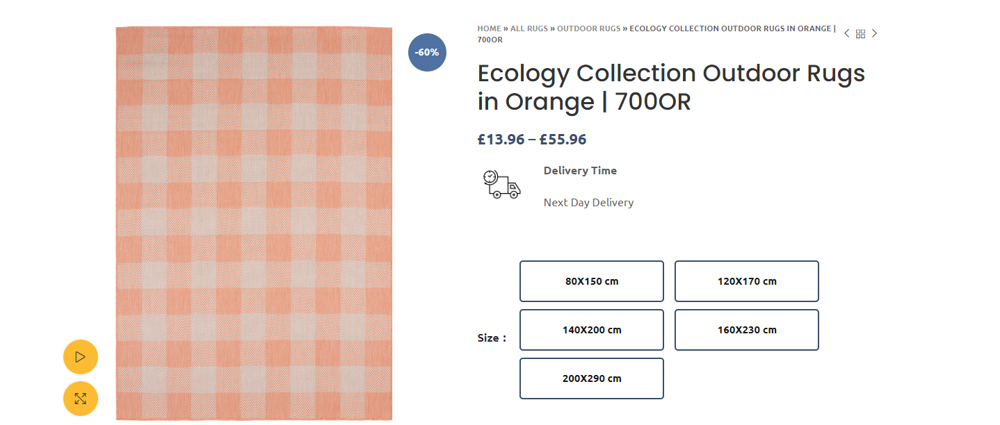

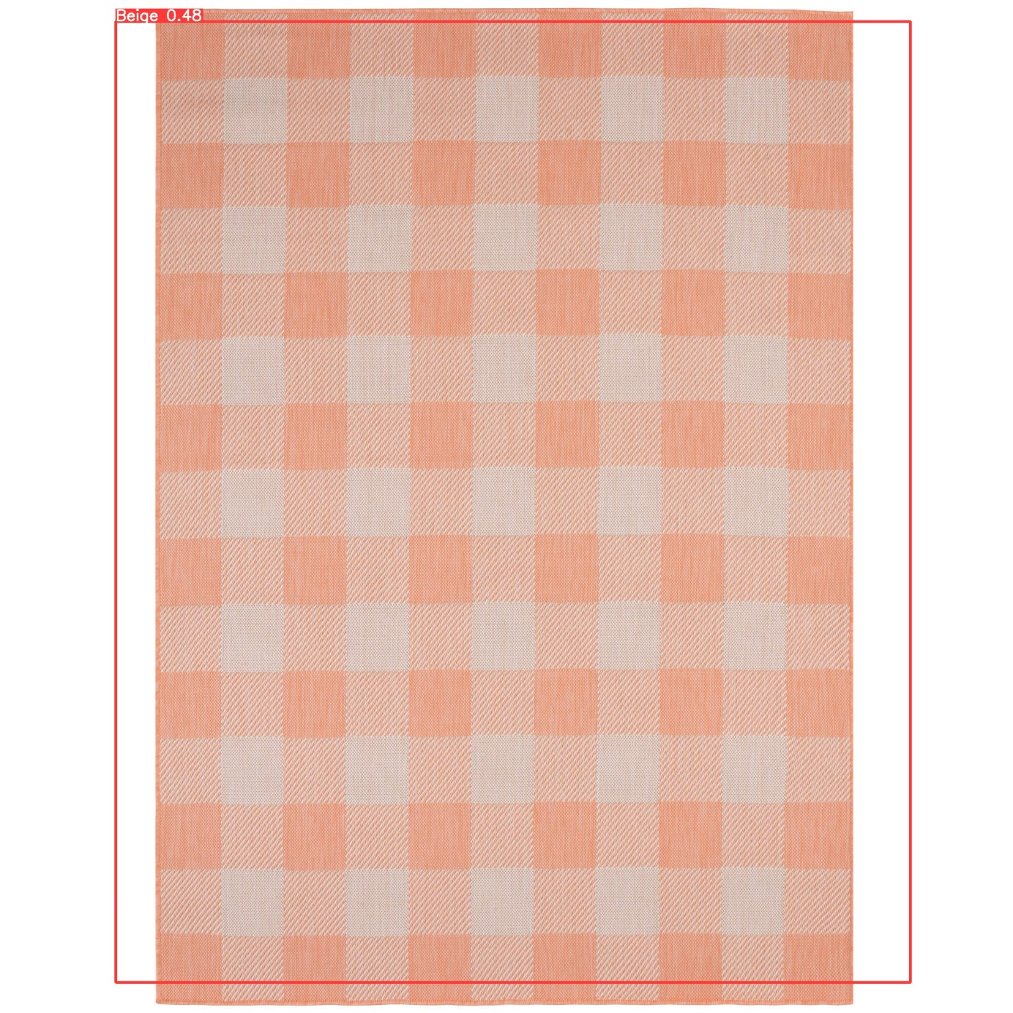

**4.Model Evaluation**

The model achieved an average confidence score of 0.42. This means that our model has difficulty distinguishing between colors. The conclusion to be drawn from here is the distinction made according to the colors of the carpets; does not give good predictive power to the model.

